Project Report

**Name:** 500_Person_Gender_Height_Weight_Index

**Report date:** September 3, 2021

**Internship Batch:** LISUM02

**Version:** 1.0

**Project by:** Melisa Gözet

**Data intake reviewer:**

**Data storage location:** <https://www.kaggle.com/yersever/500-person-gender-height-weight-bodymassindex>

**Project Location:** https://github.com/melisagozet/BMI_Predict_on_Flask.git

**Context**

Body mass index is a value derived from the mass and height of a person. The BMI is defined as the body mass divided by the square of the body height, and is expressed in units of kg/m², resulting from mass in kilograms and height in metres.

**Content**

The dataset contains information about gender, height, weight and BMI index of individuals

Gender : Male / Female

Height : Number (cm)

Weight : Number (Kg)

**Index**

0 - Extremely Weak

1 - Weak

2 - Normal

3 - Overweight

4 - Obesity

5 - Extreme Obesity

1. **Modeling the dataset “500_Person_Gender_Height_Weight_Index.csv”**

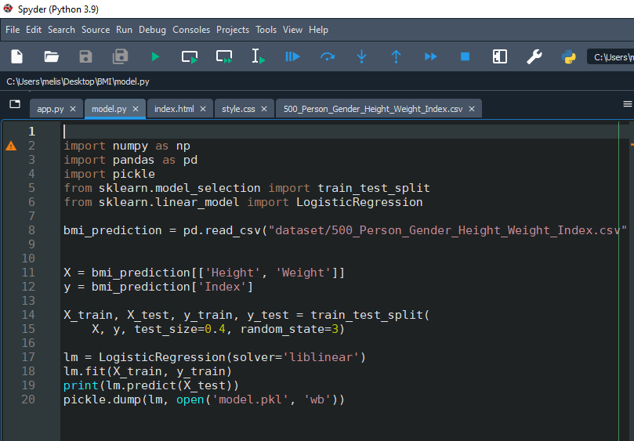

1. **HTML codes (index.html)**

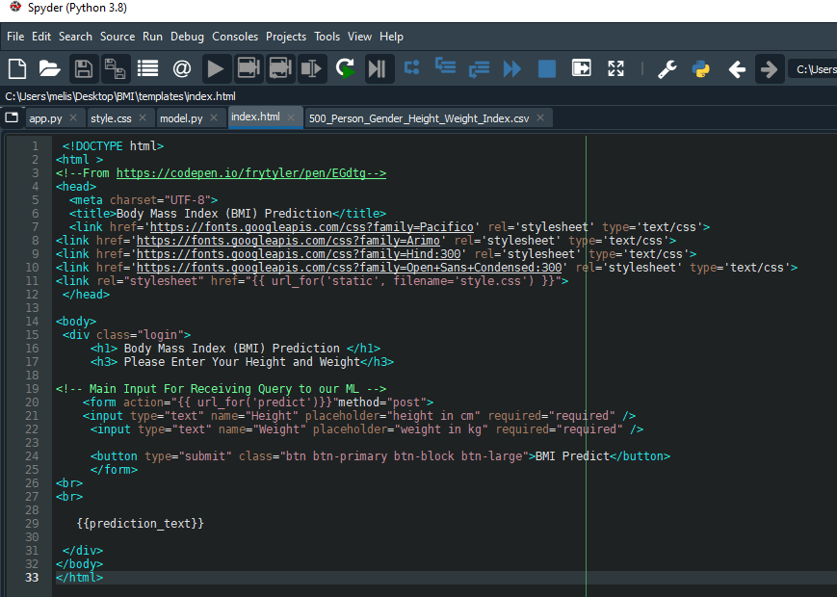

1. **app.py**

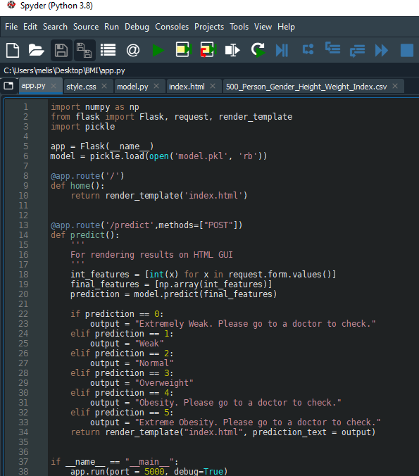

1. **Converting notebook to .py file and running python code**

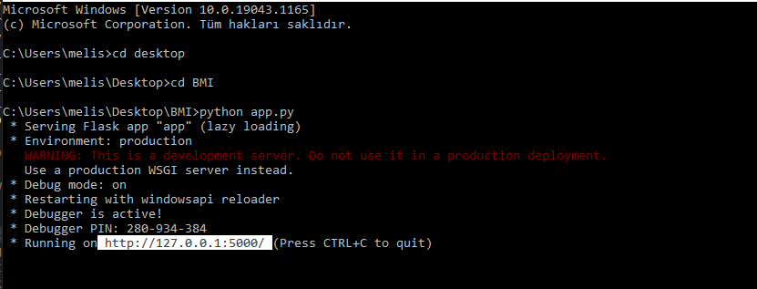

1. **Examples of the model**

